**AIM: To study different types of file operations and shared preferences**

**TITLE: Study of different types of file operations and shared preferences**

* **Theory:**
  + **File Operations:**

1. Reading and Writing files in Android will be helpful if you want to read data from SD Card, store your application data as a text file.
2. Two classes are used for file operations in android:
   1. **FileWriter** :

A specialised Writer that writes to a file in the file system. All write requests made by calling methods in this class are directly forwarded to the equivalent function of the underlying operating system. Since this may induce some performance penalty, in particular if many small write requests are made, a FileWriter is often wrapped by a BufferedWriter.

* 1. **FileReader** :

A specialised Reader that reads from a file in the file system. All read requests made by calling methods in this class are directly forwarded to the equivalent function of the underlying operating system. Since this may induce some performance penalty, in particular if many small read requests are made, a FileReader is often wrapped by a BufferedReader.

* + **Shared Preferences:**

1. Shared Preference in Android are used to save data based on key-value pair.
2. Shared means to distribute data within and preference means something important or preferable, so SharedPreferences data is shared and preferred data.
3. Shared Preference can be used to save primitive data type: string, long, int, float and Boolean.
4. A preference file is actually an xml file saved in internal memory of device. Every application have some data stored in memory in a directory data/data/application package name i.e data/data/com.practical4aandroid.4a so whenever getSharedPreferences(String name,int mode) function get called it validates the file that if it exists or it doesn’t then a new xml is created with passed name.
5. Context is an abstract class used to get global information in Android Application resources like strings, values, drawables, assets etc. Here modes are declared and static final constant in Context class.
6. There are three types of Mode in Shared Preference:
   1. **Context.MODE_PRIVATE** : default value (Not accessible outside of your application)
   2. **Context.MODE_WORLD_READABLE** : readable to other apps
   3. **Context.MODE_WORLD_WRITEABLE** : read/write to other apps

**A) Program to create a file in a directory and perform following file operations.**

**a) Write into a file**

**b) Read from a file**

**c) Delete a file.**

* **CODE:**
  + **activity_main.xml:**

<?xml version="1.0" encoding="utf-8"?>  
<androidx.constraintlayout.widget.ConstraintLayout xmlns:android="http://schemas.android.com/apk/res/android"  
 xmlns:app="http://schemas.android.com/apk/res-auto"  
 xmlns:tools="http://schemas.android.com/tools"  
 android:layout_width="match_parent"  
 android:layout_height="match_parent"  
 tools:context=".MainActivity">  
  
 <EditText  
 android:id="@+id/to_file"  
 android:layout_width="405dp"  
 android:layout_height="146dp"  
 android:ems="10"  
 android:inputType="textMultiLine"  
 android:hint="Enter Text To Add To File"  
 app:layout_constraintBottom_toBottomOf="parent"  
 app:layout_constraintEnd_toEndOf="parent"  
 app:layout_constraintHorizontal_bias="0.427"  
 app:layout_constraintStart_toStartOf="parent"  
 app:layout_constraintTop_toTopOf="parent"  
 app:layout_constraintVertical_bias="0.023" />  
  
 <Button  
 android:id="@+id/insert"  
 android:layout_width="121dp"  
 android:layout_height="60dp"  
 android:onClick="write"  
 android:text="INSERT"  
 app:layout_constraintBottom_toBottomOf="parent"  
 app:layout_constraintEnd_toEndOf="parent"  
 app:layout_constraintStart_toStartOf="parent"  
 app:layout_constraintTop_toTopOf="parent"  
 app:layout_constraintVertical_bias="0.302" />  
  
 <Button  
 android:id="@+id/del"  
 android:layout_width="121dp"  
 android:layout_height="60dp"  
 android:text="DELETE"  
 android:onClick="delete"  
 app:layout_constraintBottom_toBottomOf="parent"  
 app:layout_constraintEnd_toEndOf="parent"  
 app:layout_constraintStart_toStartOf="parent"  
 app:layout_constraintTop_toTopOf="parent"  
 app:layout_constraintVertical_bias="0.931" />  
  
 <Button  
 android:id="@+id/read"  
 android:layout_width="121dp"  
 android:layout_height="60dp"  
 android:text="READ"  
 android:onClick="read"  
 app:layout_constraintBottom_toBottomOf="parent"  
 app:layout_constraintEnd_toEndOf="parent"  
 app:layout_constraintStart_toStartOf="parent"  
 app:layout_constraintTop_toTopOf="parent"  
 app:layout_constraintVertical_bias="0.701" />  
  
 <TextView  
 android:id="@+id/fro_file"  
 android:layout_width="405dp"  
 android:layout_height="124dp"  
 android:text="TextView"  
 app:layout_constraintBottom_toBottomOf="parent"  
 android:singleLine="false"  
 app:layout_constraintEnd_toEndOf="parent"  
 app:layout_constraintStart_toStartOf="parent"  
 app:layout_constraintTop_toTopOf="parent" />  
</androidx.constraintlayout.widget.ConstraintLayout>

* + **MainActivity.java:**

package com.example.practical4_a;  
  
import androidx.appcompat.app.AppCompatActivity;  
  
import android.content.Context;  
import android.os.Bundle;  
import android.view.View;  
import android.widget.Button;  
import android.widget.EditText;  
import android.widget.TextView;  
import android.widget.Toast;  
  
import java.io.BufferedReader;  
import java.io.File;  
import java.io.FileInputStream;  
import java.io.FileNotFoundException;  
import java.io.FileOutputStream;  
import java.io.IOException;  
import java.io.InputStream;  
import java.io.InputStreamReader;  
import java.io.OutputStreamWriter;  
  
public class MainActivity extends AppCompatActivity {  
 Button ins,red,del;  
 TextView t1;  
 EditText e1;  
 @Override  
 protected void onCreate(Bundle savedInstanceState) {  
 super.onCreate(savedInstanceState);  
 setContentView(R.layout.activity_main);  
  
 t1=findViewById(R.id.fro_file);  
 e1=findViewById(R.id.to_file);  
 ins=findViewById(R.id.insert);  
 red=findViewById(R.id.read);  
 del=findViewById(R.id.del);  
  
 }  
  
  
 public void write(View v) {  
 String filename="myfile.txt";  
 String data=e1.getText().toString();  
  
 FileOutputStream fos;  
 try {  
 fos = openFileOutput(filename, Context.MODE_APPEND);  
 //default mode is PRIVATE, can be APPEND etc.  
 fos.write(data.getBytes());  
 fos.close();  
  
 Toast.makeText(getApplicationContext(),filename + " saved",  
 Toast.LENGTH_LONG).show();  
  
  
 } catch (FileNotFoundException e) {Toast.makeText(getApplicationContext(),"FILE NOT FOUND",  
 Toast.LENGTH_LONG).show();;}  
 catch (IOException e) {e.printStackTrace();}  
 }  
  
 public void delete(View v) {  
 deleteFile("myfile.txt");  
 Toast.makeText(getApplicationContext(),"FILE DELETED!!!", Toast.LENGTH_LONG).show();  
 }  
  
  
  
   
 public void read(View view) {  
 StringBuffer stringBuffer = new StringBuffer();  
 try {  
 //Attaching BufferedReader to the FileInputStream by the help of InputStreamReader  
 BufferedReader inputReader = new BufferedReader(new InputStreamReader(openFileInput("myfile.txt")));  
 String inputString;  
 //Reading data line by line and storing it into the stringbuffer  
 while ((inputString = inputReader.readLine()) != null) {  
 stringBuffer.append(inputString + "\n");  
 }  
 t1.setText(stringBuffer.toString());  
 } catch (FileNotFoundException e)  
 {Toast.makeText(getApplicationContext(),"FILE NOT FOUND", Toast.LENGTH_LONG).show();}  
 catch (IOException e) {  
 e.printStackTrace();  
 }  
 }  
  
 }

* **OUTPUT:** 
  + **GUI After Entering To File**

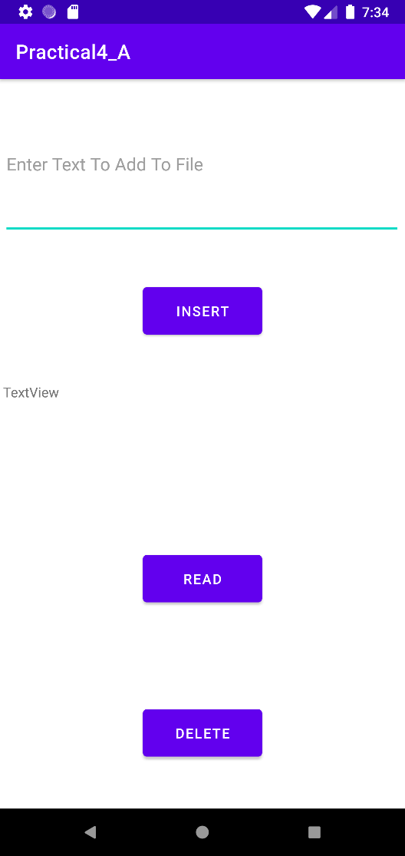 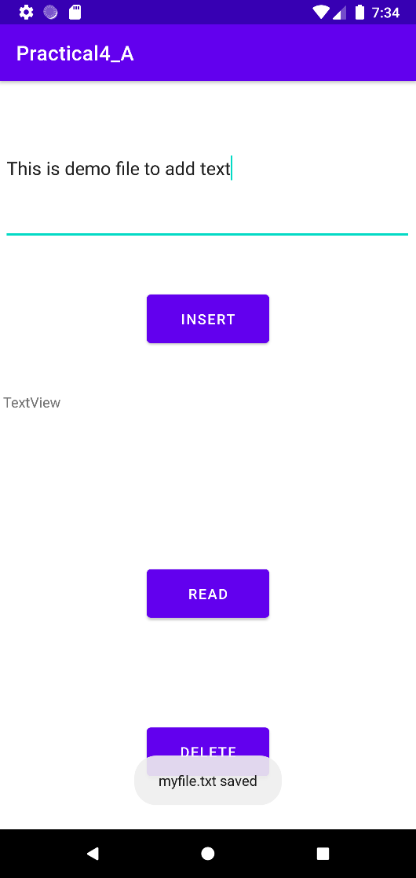

* **Display File Attributes Delete File**

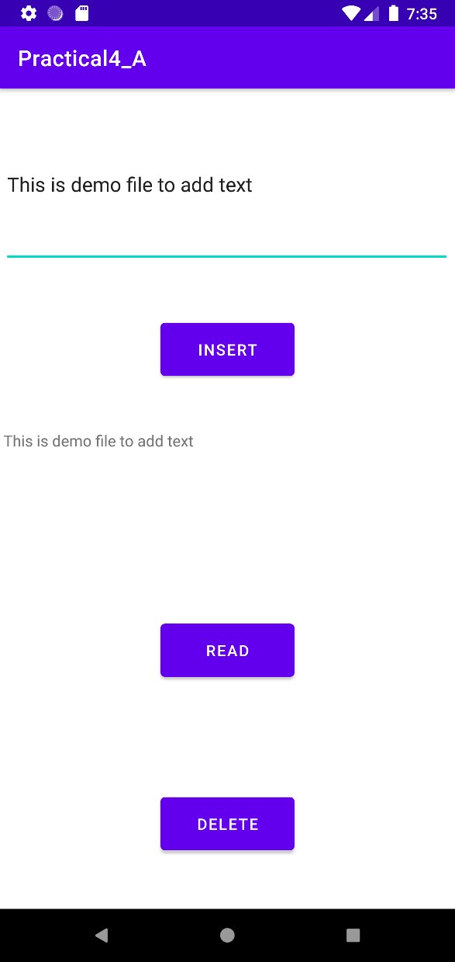 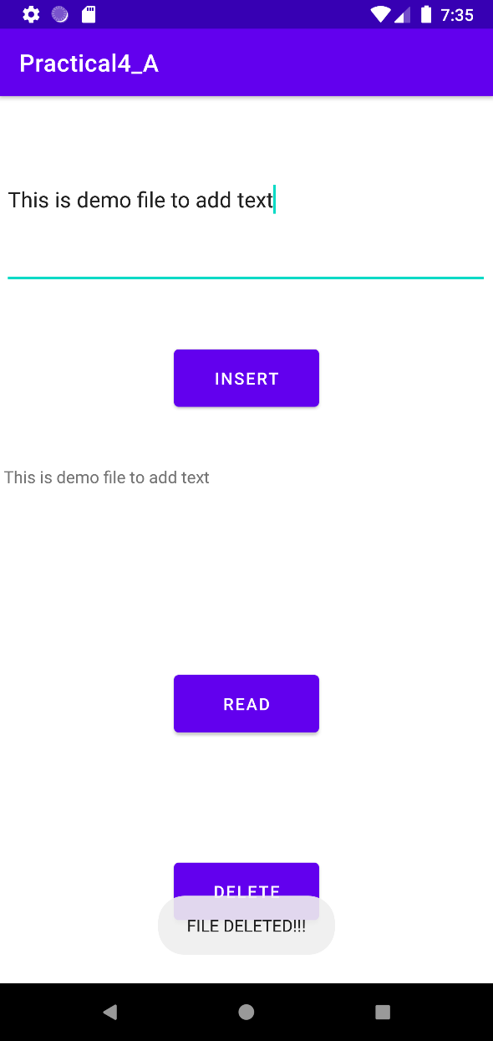

**B) Create a new project and create a login Activity. In this create a**

**login UI asking user email and password with an option of**

**remember me checkbox. Also a button displaying Sign In or**

**Register using shared preferences.**

* **CODE:**
  + **activity_main.xml:**

<?xml version="1.0" encoding="utf-8"?>  
<androidx.constraintlayout.widget.ConstraintLayout xmlns:android="http://schemas.android.com/apk/res/android"  
 xmlns:app="http://schemas.android.com/apk/res-auto"  
 xmlns:tools="http://schemas.android.com/tools"  
 android:layout_width="match_parent"  
 android:layout_height="match_parent"  
 tools:context=".MainActivity">  
  
 <TextView  
 android:id="@+id/textView"  
 android:layout_width="182dp"  
 android:layout_height="49dp"  
 android:text="LOGIN"  
 android:textAlignment="center"  
 android:textSize="30sp"  
 android:textStyle="bold"  
 app:layout_constraintBottom_toBottomOf="parent"  
 app:layout_constraintEnd_toEndOf="parent"  
 app:layout_constraintHorizontal_bias="0.497"  
 app:layout_constraintStart_toStartOf="parent"  
 app:layout_constraintTop_toTopOf="parent"  
 app:layout_constraintVertical_bias="0.043" />  
  
 <EditText  
 android:id="@+id/pass"  
 android:layout_width="wrap_content"  
 android:layout_height="wrap_content"  
 android:ems="10"  
 android:hint="Enter Password"  
 android:inputType="textPassword"  
 android:minHeight="48dp"  
 app:layout_constraintBottom_toBottomOf="parent"  
 app:layout_constraintEnd_toEndOf="parent"  
 app:layout_constraintHorizontal_bias="0.497"  
 app:layout_constraintStart_toStartOf="parent"  
 app:layout_constraintTop_toTopOf="parent"  
 app:layout_constraintVertical_bias="0.341"  
 tools:ignore="MissingConstraints" />  
  
 <Button  
 android:id="@+id/log"  
 android:layout_width="106dp"  
 android:layout_height="52dp"  
 android:onClick="onClick"  
 android:text="LOGIN"  
 app:layout_constraintBottom_toBottomOf="parent"  
 app:layout_constraintEnd_toEndOf="parent"  
 app:layout_constraintHorizontal_bias="0.498"  
 app:layout_constraintStart_toStartOf="parent"  
 app:layout_constraintTop_toTopOf="parent"  
 app:layout_constraintVertical_bias="0.586"  
 tools:ignore="MissingConstraints,OnClick" />  
  
 <CheckBox  
 android:id="@+id/share"  
 android:layout_width="145dp"  
 android:layout_height="48dp"  
 android:text="Remember Me"  
 app:layout_constraintBottom_toBottomOf="parent"  
 app:layout_constraintEnd_toEndOf="parent"  
 app:layout_constraintHorizontal_bias="0.375"  
 app:layout_constraintStart_toStartOf="parent"  
 app:layout_constraintTop_toTopOf="parent"  
 app:layout_constraintVertical_bias="0.459" />  
  
 <EditText  
 android:id="@+id/user"  
 android:layout_width="wrap_content"  
 android:layout_height="wrap_content"  
 android:ems="10"  
 android:hint="Enter E-Mail"  
 android:inputType="textEmailAddress"  
 android:minHeight="48dp"  
 app:layout_constraintBottom_toBottomOf="parent"  
 app:layout_constraintEnd_toEndOf="parent"  
 app:layout_constraintHorizontal_bias="0.497"  
 app:layout_constraintStart_toStartOf="parent"  
 app:layout_constraintTop_toTopOf="parent"  
 app:layout_constraintVertical_bias="0.239"  
 tools:ignore="MissingConstraints" />  
  
</androidx.constraintlayout.widget.ConstraintLayout>

* + **activity_display.xml:**

<?xml version="1.0" encoding="utf-8"?>  
<androidx.constraintlayout.widget.ConstraintLayout xmlns:android="http://schemas.android.com/apk/res/android"  
 xmlns:app="http://schemas.android.com/apk/res-auto"  
 xmlns:tools="http://schemas.android.com/tools"  
 android:layout_width="match_parent"  
 android:layout_height="match_parent"  
 tools:context=".Display">  
  
 <TextView  
 android:id="@+id/textView2"  
 android:layout_width="355dp"  
 android:layout_height="113dp"  
 android:textAlignment="center"  
 android:textSize="30sp"  
 android:textStyle="bold"  
 app:layout_constraintBottom_toBottomOf="parent"  
 app:layout_constraintEnd_toEndOf="parent"  
 app:layout_constraintStart_toStartOf="parent"  
 app:layout_constraintTop_toTopOf="parent" />  
  
 <Button  
 android:id="@+id/button"  
 android:layout_width="wrap_content"  
 android:layout_height="wrap_content"  
 android:text="Clear Data"  
 android:onClick="onClick"  
 app:layout_constraintBottom_toBottomOf="parent"  
 app:layout_constraintEnd_toEndOf="parent"  
 app:layout_constraintHorizontal_bias="0.498"  
 app:layout_constraintStart_toStartOf="parent"  
 app:layout_constraintTop_toTopOf="parent"  
 app:layout_constraintVertical_bias="0.865" />  
</androidx.constraintlayout.widget.ConstraintLayout>

* + **MainActivity.java:**

package com.example.practical4_b;  
  
import androidx.appcompat.app.AppCompatActivity;  
  
import android.content.Intent;  
import android.content.SharedPreferences;  
import android.os.Bundle;  
import android.view.View;  
import android.widget.CheckBox;  
import android.widget.EditText;  
import android.widget.Toast;  
  
public class MainActivity extends AppCompatActivity {  
 EditText user,pass;  
 CheckBox cb;  
 SharedPreferences sharedPreferences;  
 boolean isRemembered;  
 @Override  
 protected void onCreate(Bundle savedInstanceState) {  
 super.onCreate(savedInstanceState);  
 setContentView(R.layout.*activity_main*);  
 user = findViewById(R.id.*user*);  
 pass = findViewById(R.id.*pass*);  
 cb = findViewById(R.id.*share*);  
 sharedPreferences = getSharedPreferences("SHARED_PREF", *MODE_PRIVATE*);  
 isRemembered = sharedPreferences.getBoolean("Checkbox", false);  
 if(isRemembered){  
 Intent intent = new Intent(MainActivity.this,Display.class);  
 startActivity(intent);  
 finish();  
 }  
 }  
 public void onClick(View view) {  
 String name = user.getText().toString();  
 boolean checked = cb.isChecked();  
 SharedPreferences.Editor editor = sharedPreferences.edit();  
 Toast.*makeText*(MainActivity.this,"Login credentials saved!",Toast.*LENGTH_SHORT*).show();  
 editor.putString("Name",name);  
 editor.putBoolean("Checkbox",checked);  
 editor.apply();  
  
 Intent intent = new Intent(MainActivity.this,Display.class);  
 startActivity(intent);  
 finish();  
  
 }  
 }

* + **Display.java:**

package com.example.practical4_b;  
import androidx.appcompat.app.AppCompatActivity;  
import android.content.Intent;  
import android.content.SharedPreferences;  
import android.os.Bundle;  
import android.view.View;  
import android.widget.TextView;  
import android.widget.Toast;  
  
public class Display extends AppCompatActivity {  
 SharedPreferences preferences;  
 @Override  
 protected void onCreate(Bundle savedInstanceState) {  
 super.onCreate(savedInstanceState);  
 setContentView(R.layout.*activity_display*);  
 TextView tv;  
  
 tv = findViewById(R.id.*textView2*);  
 preferences=getSharedPreferences("SHARED_PREF",*MODE_PRIVATE*);  
 String name=preferences.getString("Name","");  
 tv.setText("Hello "+name+" !");  
 }  
  
 public void onClick(View view) {  
 SharedPreferences.Editor editor = preferences.edit();  
 editor.clear();  
 editor.apply();  
 Intent intent = new Intent(Display.this, MainActivity.class);  
 Toast.*makeText*(Display.this,"Login credentials removed!",Toast.*LENGTH_SHORT*).show();  
 startActivity(intent);  
 finish();  
 }  
}

* **OUTPUT:**
  + **GUI Enter Data**

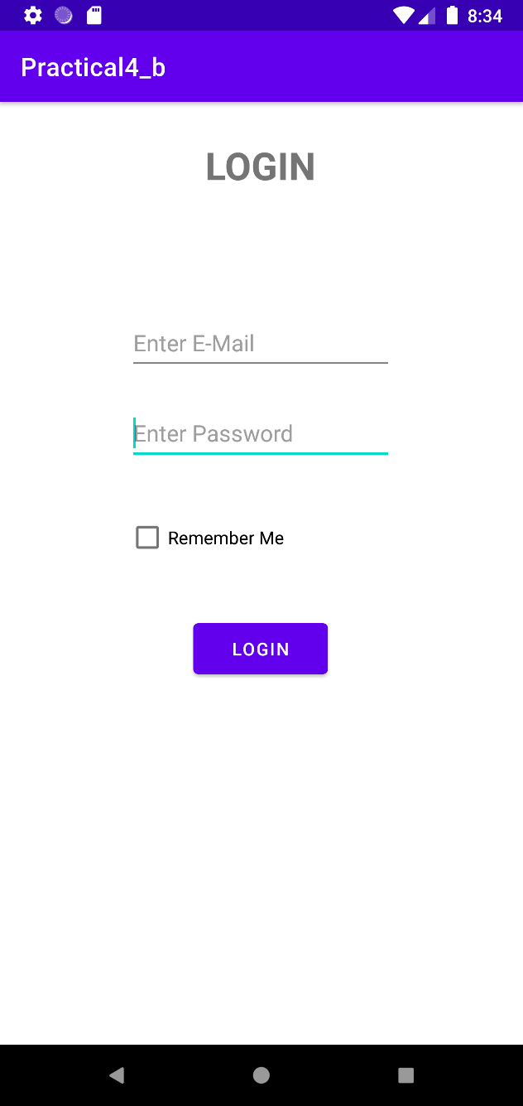 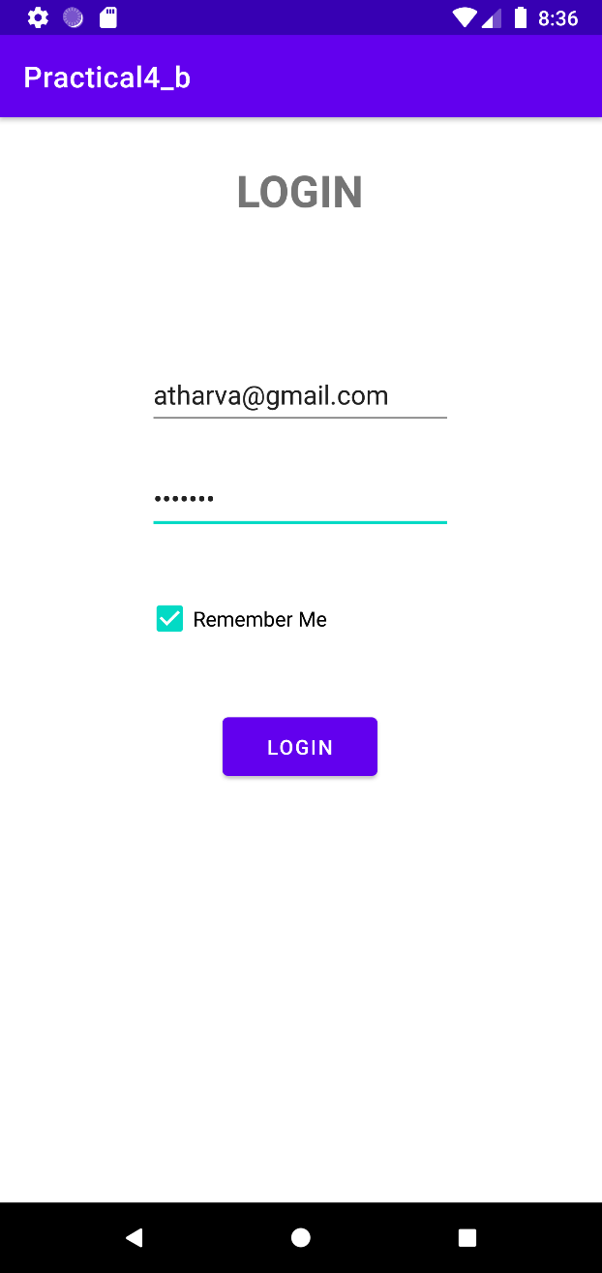

* **Credentials saved** **Credentials Removed**

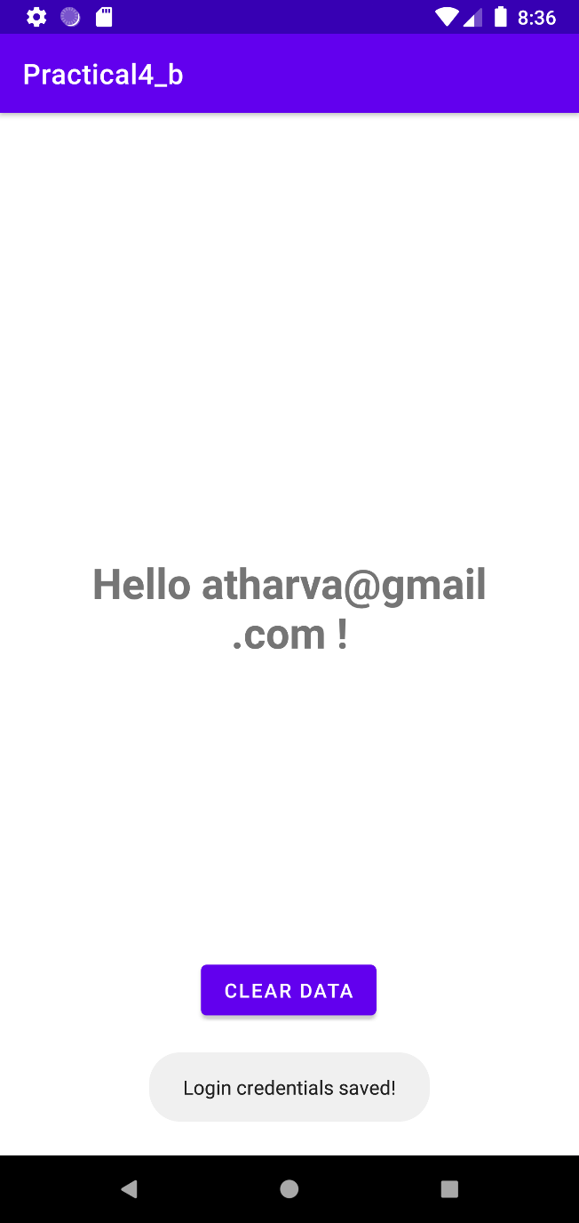 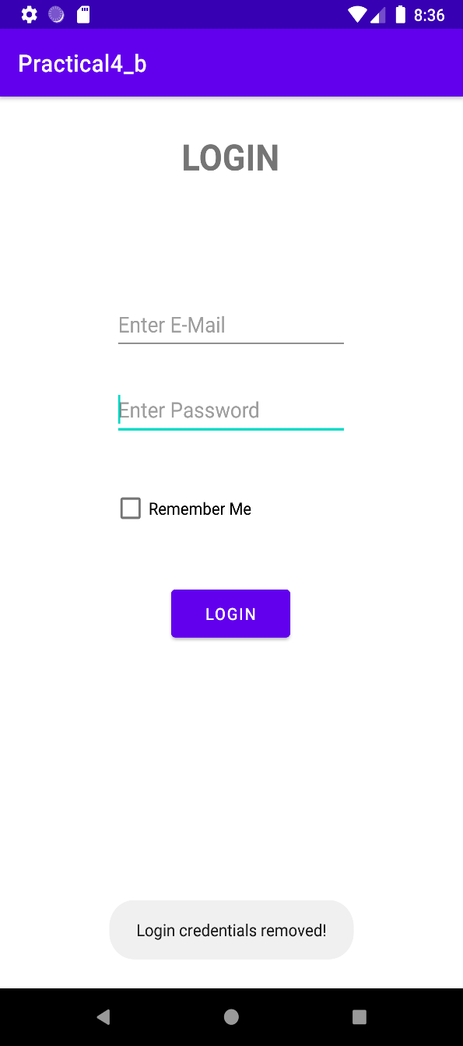

* **Conclusion:**

Hence we successfully studied different file operations and shared preferences.